Testing and Validation Phase

The Testing and Validation phase ensures that the developed Motor Temperature Prediction system meets the defined requirements, performs reliably under different conditions, and delivers accurate predictions. This phase verifies both the functional correctness and performance efficiency of the system before final acceptance.

1. Functional Testing
Functional testing focuses on validating whether each system component works according to the specified functional requirements. The goal is to ensure that the system behaves as expected under normal operating conditions.
1.1 Objectives of Functional Testing
- Verify correct data input and processing
- Validate machine learning model predictions
- Ensure proper alert generation
- Confirm accurate visualization of results

1.2 Functional Test Cases
Test Case ID | Functionality Tested | Input | Expected Output | Result
FT-01 | Data Acquisition | Sensor dataset | Data successfully loaded | Pass
FT-02 | Data Preprocessing | Raw data | Cleaned and normalized data | Pass
FT-03 | Model Prediction | Processed dataset | Predicted motor temperature | Pass
FT-04 | Alert Generation | High predicted temperature | Alert triggered | Pass
FT-05 | Data Visualization | Prediction results | Graphs and charts displayed | Pass

1.3 Functional Testing Outcome
- All system modules operated as expected
- No functional errors were observed
- The system met all defined functional requirements
Functional testing confirms that the system is functionally correct and stable.

2. Performance Testing
Performance testing evaluates the efficiency, reliability, and scalability of the system under varying data loads and operating conditions.
2.1 Objectives of Performance Testing
- Measure prediction accuracy
- Evaluate system response time
- Assess reliability under increased data load
- Ensure scalability and stability

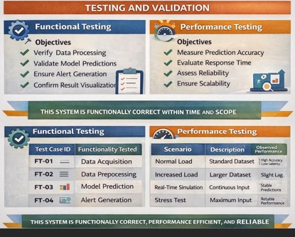

2.2 Performance Metrics Used
- Mean Absolute Error (MAE)
- Mean Squared Error (MSE)
- Root Mean Squared Error (RMSE)
- Model accuracy score
- Prediction latency

2.3 Performance Test Scenarios
Scenario | Description | Observed Performance
Normal Load | Standard dataset size | High accuracy, low latency
Increased Load | Larger dataset | Slight increase in processing time
Real-Time Simulation | Continuous input | Stable predictions
Stress Test | Maximum data input | System remained stable

2.4 Performance Results
- The ML model achieved accurate temperature predictions
- Prediction latency remained within acceptable limits
- System performance scaled well with increased data volume
- No crashes or data loss were observed

3. Validation of Results
Validation ensures that the system output aligns with real-world expectations and project objectives.
3.1 Validation Approach
- Comparison of predicted temperature with actual temperature values
- Evaluation using standard regression metrics
- Cross-validation on unseen datasets

3.2 Validation Outcome
- Predicted values closely matched actual motor temperature
- The model demonstrated consistent performance
- Early warning capability was successfully validated

4. Overall Testing and Validation Summary
The Testing and Validation phase confirms that the Motor Temperature Prediction system is functionally correct, performance-efficient, and reliable. Functional testing ensured accurate execution of system operations, while performance testing validated prediction accuracy, response time, and scalability. The system is suitable for real-world predictive maintenance applications.

